


2025
Manual
Identification Cognitive talent
COVAT-3 (EGE-module) & SES
Katrijn Van Parijs
Marlies Tierens
Walter Magez
Steven Joris
Sophie De Grauwe

September 2025

© Copyright 2025
Publisher: Expertise Centre for Care and Welfare, Thomas More Antwerp Molenstraat 8, 2018 Antwerp, Belgium www.thomasmore.be Editor: Research Group People and Welfare, Thomas More Antwerp
Authors: K. Van Parijs, M. Tierens, W. Magez, S. Joris & S. De Grauwe
All rights reserved. No part of this publication may be reproduced and/or stored in a retrieval system, and/or made public, in any form or by any means, whether by means of print, photocopy, microfilm, recording, mechanical or by any other means, without the prior written permission of the publisher.

All rights reserved. No part of this publication may be reproduced, stored in a retrieval system, or transmitted, in any form or by any means, electronic, mechanical, photocopying, recording, or otherwise, without the prior written permission of the publisher.

COVAT-3 (EGE module)

Explanation of the instrument
The COVAT-3 is a digital cognitive ability test, based on the Cattell-Horn-Carroll (CHC) model of intelligence. The instrument is used in school psychological, clinical and work contexts to map cognitive skills.

The EGE module focuses on one broad cognitive skill: fluid reasoning – the purposeful and flexible solving of new problems that cannot be addressed automatically (McGrew, 2009).

The EGE module consists of two subtests:
- Pattern: The student continues pattern series based on a self-discovered rule. The subtest measures inductive (I) and deductive reasoning (RG).
- Shapes: The student finds out the value of symbols by reasoning. The subtest is quantitative reasoning (RQ).

Each subtest has the same structure:
- Instructional video: visual explanation based on step-by-step solved examples.
- Practice items: practice independently to become familiar with assignment and response method.
- Test items: the actual test administration.

More information about the CHC model can be found on the CHC platform.

Sampling time and duration
The test is preferably taken in the morning, when the student can concentrate even better.

Maximum (programmed) test times per subtest, this is without instruction film & practice items:
- Pattern: 25 minutes
- Shapes: 35 minutes

The total duration is an estimate, as factors such as skipping or rewatching instructional videos and individual speed (for practice and test items) vary. Once a student is done, the subtest can be completed and moved on to the next, regardless of the time remaining. As a result, the administration is completely individual and at your own pace.

Each subtest will be administered without interruption. If desired, a break can only take place between the two subtests. The entire module is preferably completed in one session.

Test Conditions and Material
The test is taken in a low-stimulus room, where only the test leader and participants are present. The room is comfortably furnished (chair, table, good view of the computer screen), with sufficient light and ventilation. Distractions are kept to a minimum.

Test administration checklist

TEST ENVIRONMENT Checklist - Prerequisites
- Sampling takes place in a separate, low-stimulus room.
- Distractions are kept to a minimum: no background noise, only necessary material on the table, mobile phones off or on silent and stored.
- Presence in the room: only the accompanying teacher(s) and the participating pupils
- The room has a comfortable chair and table, where the participant has a clear view of the computer screen.
- Sufficient lighting, good ventilation and a pleasant room temperature are provided.

Checklist required MATERIAL
For each participant
- Computer: desktop or laptop (for laptops: adapter connected or battery sufficiently charged; estimated test time ± 90 minutes (incl. questionnaire SES).
- Software & connection: correct working operating system, stable internet connection and correct browser.
- Peripherals: screen and keyboard (if applicable), mobile mouse if possible
- Writing and writing aids (only for COVAT Shapes): scrap paper, 2 ballpoint pens/pencils (one for spare).
- Administrative documents: identification form with personal login/code
- Personal aids: e.g. glasses or other necessary support.

For test leader
- Script: digital or printed copy.
- Administration: overview of the login data created.
- Observation material: note paper for observations and recording of technical problems.

Preparation for the test

Preparations prior to taking the test
- Informed consent:
Consent from parent(s) or legal representative(s) is required for minor participants. Make sure you have this permission in advance. Without permission, the test cannot take place.

- Login details for the online test platform:
  - Surf to the TASC test platform via https://login.tascnet.be/ and log in with the following details
    - Username: THMO.EGEtalentIRL
    - Password: EGE2526
(or directly via: https://tascnet.be/tlogin?token=ae97879707125642ca317ff6151b1f8a)
  - TIP: if you see Dutch words: in the top right corner you can choose “English” as language
  - As a teacher, always fill in "test" by name and code (this way your data will be deleted and not accidentally included in the research)
  - TIP: if you want to go through the test questions quickly , enter a WRONG answer each time, after 10 wrong answers the test ends automatically.
  - If there are any problems, please contact marlies.tierens@thomasmore.be or assessmenthub@thomasmore.be

- Create a list of codes
Create a unique code for each student to ensure the anonymity of the students. The student can enter this (instead of the name) during all registrations for the study, such as the test administration, questions about background, possibly pre- and post-test.

NOTE: start this code with one letter for the country and two letters that refer to your school. Use the following letters for the country:
- N: Netherlands
- B: Belgium
- I: Ireland
- K: Kosovo
e.g. Belgian school with the name Sapiens could then receive three letters BSA as the first, to which a unique letters/number combination of the student is added.

- As a test leader, prepare for the test administration
Familiarize yourself with the assignments and content of the subtests. Make sure you are sufficiently aware of the background and method of taking the test.

- Prepare the students: assignment on questioning background data
Instruct the students at least two days in advance to inquire with their parents about the following information
- Highest education father/mother
- Father/mother's occupation
- Father/mother country of birth

Preparations for the day of the test
- Control equipment
Check that all the required equipment is present (see checklist for required equipment).

- Start computers
  - Pre-start all computers if possible.
  - For laptops: Plug in the adapter.
  - Check the correct browser and a stable internet connection.
  - If possible, provide some spare computers as a backup.
- Prepare the test module for the students
  - Surf to the TASC test platform via https://login.tascnet.be/ and log in with the following details
    - Username: THMO.EGEtalentIRL
    - Password: EGE2526
(or directly via: https://tascnet.be/tlogin?token=ae97879707125642ca317ff6151b1f8a)
  - TIP: if you see Dutch words: in the top right corner you can choose “English” as language
  - Provide each participant with the personal code that is entered instead of their name. ATTENTION: If the code is entered incorrectly, the results cannot be correctly linked to the student. (for this reason, the code is requested at different times)
- Start of test assessment
  - The test starts immediately after logging in.

Progress of the test assessment

Introduction
- Go through the information related to the informed consent
  - Discuss with the students that their parents have given permission to participate and that participation is completely voluntary.
  - Explain that they can decide to stop at any time, but that they will not be able to participate in the further investigation.
  - Mention that the data is processed anonymously and will not be shared with others
- Explain the general structure of the test (see 3.2).
  - Explain that the tasks are alternately simpler and more difficult.
  - Tell them that the same assignments are also given to adults or university students and that it is normal for them not to be able to fill in all the answers correctly.
  - Discuss that they can skip questions if they don't know the answer, they may be able to solve the next question. They continue until the test system indicates that the test has been completed.
  - Time information to participants:
    - Explain that each subtest takes about half an hour; This does not include the time for instructions and practice items.
    - The participants can see how much (maximum) time they have left for the entire subtest at the top right of the screen. However, it is also possible that the test stops earlier.
    - A time limit is also set for each individual question. When the bar at the top right starts to fill, it means that there are about 10 seconds left.
    - Emphasize that it is not a problem if a participant cannot answer a question within the time. The following questions can still be solved.
  - Indicate that afterwards a number of questions must be completed via an online questionnaire about their background and that of their parents and their school (see 2.1, point 5).
- Provide the login details to the participants.
  - Each student receives a username and password. These can be mentioned on the identification form, for example, or distributed separately. The participants log in themselves with the login details created for them.

General introduction to the module
Before the students log in and start taking the actual test, you explain the general procedure of the test:

This test measures various thinking skills and is administered entirely online. For the two tasks, you will first see an instructional video explaining what to do. Then you make a number of practice exercises. You will immediately receive feedback on whether your solution is correct or not. Only then do you start the actual task. Here the computer no longer says whether you answer correctly or incorrectly.

You will notice that the tasks are alternately easier and more difficult in the beginning and that you have to think more towards the end. It's not a problem at all if you can't solve all the problems. The test is made in such a way that no one can solve everything. The most important thing is that you do your best and work on the assignments focused and without losing time.

Don't look at your neighbour’s screen and don't look for anything on the internet. If you have any questions, feel free to call me.

You can now log in to the platform and start with the first assignment. If you see Dutch words, you can change this in the top right corner: there you can choose “English” as language. You work at your own pace and go through the test all by yourself

Points of attention during the test assessment
- Only the test platform is active in browser: Verify that no other tabs or browser instances are open (browser at the top, taskbar at the bottom).

- Do not use other applications : For example, calculators; check the taskbar for running programs.

- Prevent copying of answers: Make sure that participants cannot see or discuss each other's answers. Also pay attention to the arrangement of the computer screens.

- Prohibited Activities: Copying or taking possession of test content (e.g., Print Screen, copy/paste) and use of mobile phones or smartwatches are strictly prohibited. Students can commit fraud with this and the test can become unusable.

- The test is designed to allow for high-quality administration on most desktops, laptops, and tablets according to the default settings. However, it is possible that the test leader has to make adjustments depending on a particular participant.
  - Zoom function: When certain items are visually unclear, it is always possible to zoom in and out and to enlarge and reduce the screen. You can use the key combination "Ctrl +" (zoom in) or "Ctrl -" (zoom out).
  - Instructional videos:
    - Visibility: use full screen right  below to enlarge the image.
    - Speed: It can be useful to tell the students that instructional videos can be paused. This can be helpful for participants who find the videos too fast in terms of pace and need more time to watch certain parts of the video better. The video can also be played faster or slower via the following steps:
      - At the bottom right, click
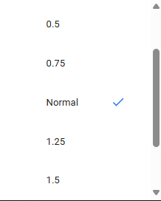
      - Then on 
      - Then choose the desired speed
Table 6. Checklist points of attention during test administration

SUPERVISION & SUPPORT DURING TEST ADMINISTRATION
 | - Make sure that only the test platform is active on the participant's computer. Check browser (at the top) and taskbar (at the bottom).  - Keep participants in sight and make sure they take the test individually .  - Check that participants do not copy or take any parts of the test.  - Provide support for computer difficulties:  - Clicking too quickly can lead to incorrect registration.  - Zoom function: zoom in Ctrl +, zoom out Ctrl –.  - Instructional videos: use theater mode or pause if necessary.
 | • Check that the participant is only using the test browser and the correct tab (see above); Other programs or browsers must not be open.  • Copying or taking possession of content elements of the test is prohibited.  • Mobile phones, smartwatches and other electronic devices are not allowed during the test.

End of the thinking tasks
- Confirm that the test has been completed and that the students have done their best. Repeat the following instruction:

"It's completely normal that you didn't do all the assignments quite right. The test is made in such a way that even adults cannot answer everything correctly. It's about seeing where your strengths and weaknesses lie if you do your best."

Thank the students and, if appropriate, other individuals for their time and cooperation.

- Close the test platform's tab and/or browser .

Background data questionnaire (SES, ESCS) & end

- Have them fill in the questions about their background via the following link (duration: +/- 15 minutes): https://forms.office.com/e/Uk50ZY6yPf

- TIP: if you see Dutch words: in the top right corner you can choose “English” as language

- Collect any identification forms or other documents that contain personal login codes and/or student identification information, and keep them in accordance with applicable guidelines.

- Thank the students

Troubleshooting

Possible technical issues
- Student is removed from the test or test gets stuck
  - The participant is removed from the test due to, for example, a poor internet connection.
    - If the first test was NOT COMPLETED:
      - during instruction or practice exercises: start again via the login details
      - during actual test administration: restart and note this to pass on to the Thomas More researchers
    - ONLY if the first test was completed, use the following login details to only take the second test:
    - Username: THMO.2_EGEtalentIRL
    - Password: EGE2526
      - (or directly via: https://tascnet.be/tlogin?token=0f4594f07dc1fb461e2edebe5ce5b744)
Please use this option as little as possible!

- The Instruction Video does not load and/or does not play
  - Check the browser: Internet Explorer is not recommended; preferably use Google Chrome, Mozilla Firefox or Microsoft Edge. In case of problems, you can switch browsers.
  - Check the internet connection, network cable, and Wi-Fi signal.
  - Alternative instruction: give the explanation yourself on the basis of standard instructions and examples, after which the participant can start with the practice items.

- Keyboard problems
If the keyboard is unexpectedly set to QWERTY instead of AZERTY or vice versa:
  - Windows 10 and later: Press Windows + Spacebar key at the same time.
  - Older Windows versions: press the Shift + Alt key at the same time.

Background information on the module

Subtests
Both subtests, Pattern and Shapes, are explained via instructional videos and practice examples in the program. In principle, this explanation is sufficient to understand the assignment and to carry it out independently. If a participant needs additional explanation, the test leader may only give it on the basis of the examples and practice items from the program; do not use any additional explanations outside the program.

Both subtests will be administered adaptively. This means that the items are adjusted to the estimated skill level of the participant: the difficulty of each subsequent item depends on the answers to the previous items. Test administration will stop when the maximum number of items is reached or when the time limit has expired.

The administration of both subtests is automatic and usually does not require the intervention of the test leader. Tools such as pencil and paper are only allowed in the Shapes subtest.

COVAT PATTERN

Contents
This test consists of different pattern series that are built up according to certain rules.
Each item consists of a series of black figures in a grid and two empty grids (see Figure 1). The participants have to discover the rule(s) and continue the sequence based on those rules by making the right figures in the empty grids.

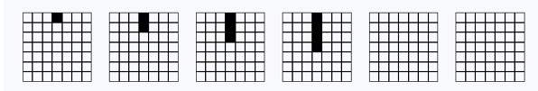
Figure 1. Sample item of the COVAT_Pattern

Testing time
- Average instruction time: 5 minutes
- Average test time: 25 minutes
- Maximum test time: 25 minutes
- Average total time: 30 minutes

How is the test administered?

Introduction
The introduction lasts 2.5 minutes and consists of an instructional video: EGE_COVAT Pattern instruction

In each exercise, the participants have to continue a given pattern series in a logical way in two empty grids at the end of the pattern series. They do this by colouring in squares in the empty grids. During the exercises, participants can watch the instructional video over and over again by clicking on the video icon:

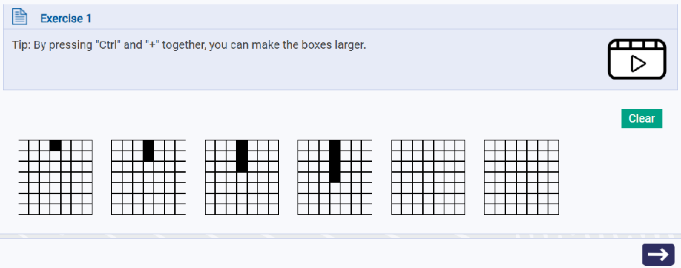

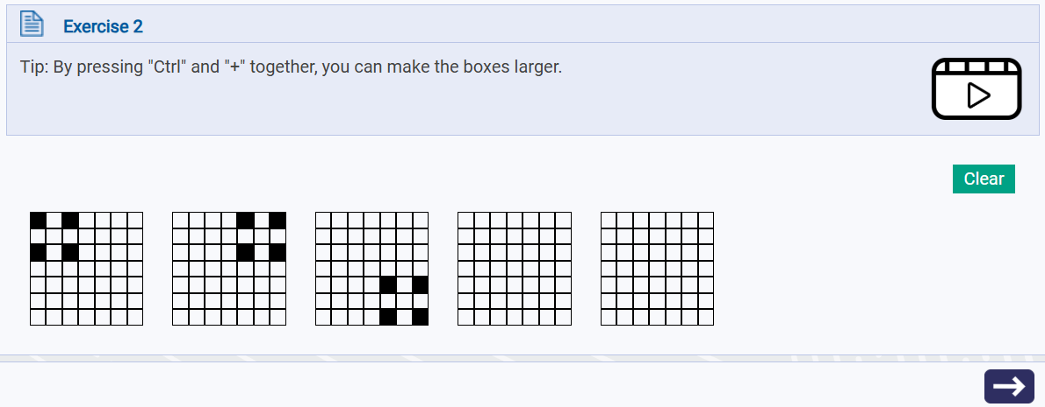

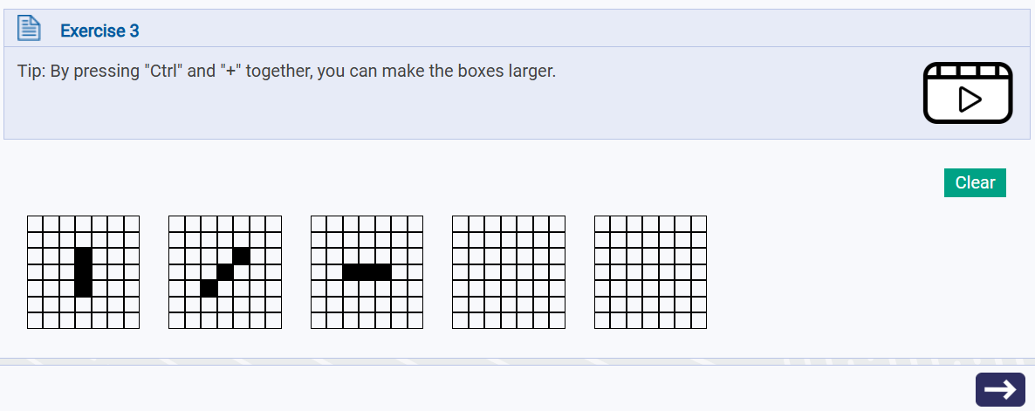
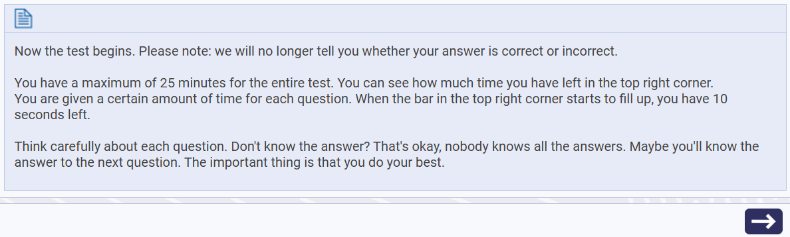

Answer
In the COVAT Pattern subtest, students have to colour in boxes in the two empty grids at the end of each pattern sequence.
- A cell is coloured by clicking on it with the mouse and can be made white again by clicking again.
- The Clear button resets all cells to white at once: 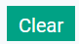
- The answer is confirmed by clicking on the arrow at the bottom right of the screen.  The arrow is always visible, even before a cell is clicked; if a participant tries to continue without selecting a cell, a warning appears.

COVAT SHAPES

! SCRAP PAPER & WRITING MATERIALS ARE RECOMMENDED, they can take this ready before the start !

Contents
This test consists of several exercises where the value of a figure is asked.
Each item consists of one or more figures in an equation (see Figure 1). The participants have to discover the value(s) of the figure(s) and enter the correct value for the figure that is requested.

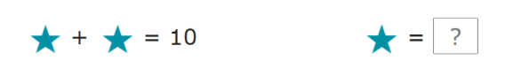
Figure 1. Sample item of the COVAT_Shapes

Testing time
- Average instruction time: 5 minutes
- Average test time: 35 minutes
- Maximum test time: 35 minutes
- Average total time: 40 minutes

How is the test administered?

Introduction
The introduction lasts +/- 2.5 minutes and consists of an instructional video: EGE_COVAT shapes instruction

For each exercise, participants have to deduce the value of the figures and enter the correct number During the exercises, participants can watch the instructional video over and over again by clicking on the video icon:

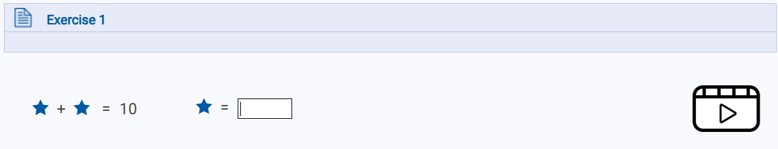

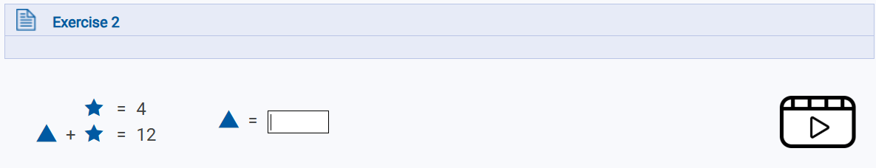

In exercise three, additional instructions are given between the traffic signs
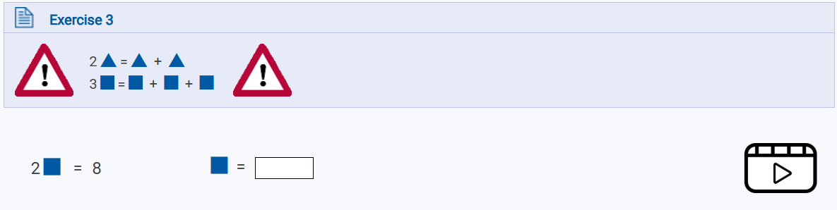

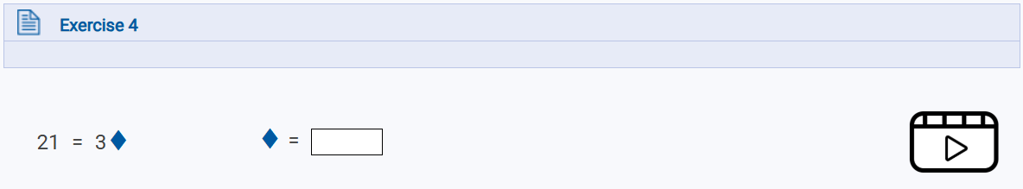
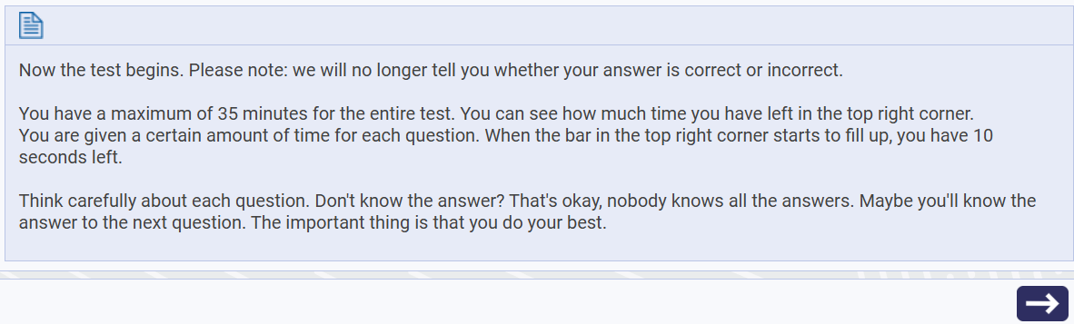

Answer
The students fill in the boxes with the number that indicates the value of the requested figure.
- All replies can be deleted by pressing Backspace.
- The answer is confirmed by clicking on the arrow at the bottom right of the screen. The arrow is always visible (except in the case of the exercises), even before a number has been entered; if a participant tries to continue without selecting a cell, a warning appears.

contact
If you have any questions or problems, please contact the researchers associated with the EGE project:
Marlies Tierens (marlies.tierens@thomasmore.be)
If the above person is not available, you can contact the staff of the Assessment Hub (assessmenthub@thomasmore.be)

Follow us
www.thomasmore.be
fb.com/ThomasMoreBE
#WeAreMore

